1.WRITE JAVA PROGRAM TO PRINT "HELLO WORLD" MESSAGE?

**package** demo;

**public** **class** sairaj {

**public** **static** **void** main(String[] args) {

// **TODO** Auto-generated method stub

System.***out***.println("Hello world");

}

}

Output:

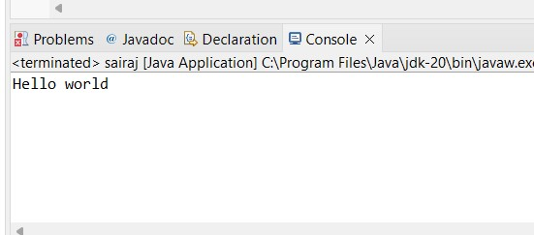

2.Write a program to find the sum of two numbers entered by the user.

package demo;

import java.util.Scanner;

public class hello {

public static void main(String[] args) {

// TODO Auto-generated method stub

int a, b, c;

Scanner s=new Scanner(System.in);

System.out.println("Enter the 1st num ");

a= s.nextInt();

System.out.println("Enter the 2nd num ");

b= s.nextInt();

c=a+b;

System.out.println("Sum is: "+c);

Output:

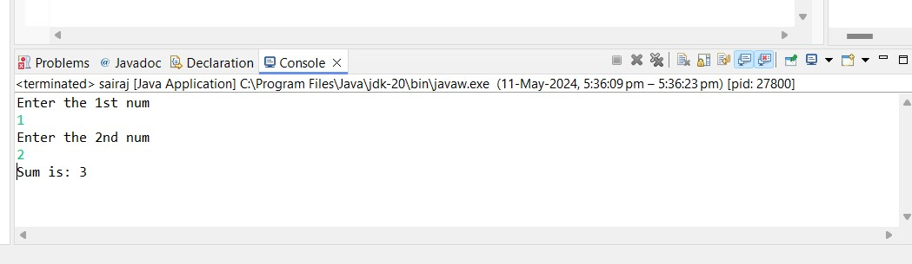

3.Write a Java program to check whether a given number is even or odd.

**package** viraj;

**import** java.util.Scanner;

**public** **class** demo2 {

**public** **static** **void** main(String[] args) {

Scanner scanner = **new** Scanner(System.***in***);

System.***out***.println("enter the num:");

**int** num=scanner.nextInt();

**if**(num % 2==0) {

System.***out***.println(num + "is even.");

}

**else**

{

System.***out***.println(num + "is odd.");

}

}

}

Output:

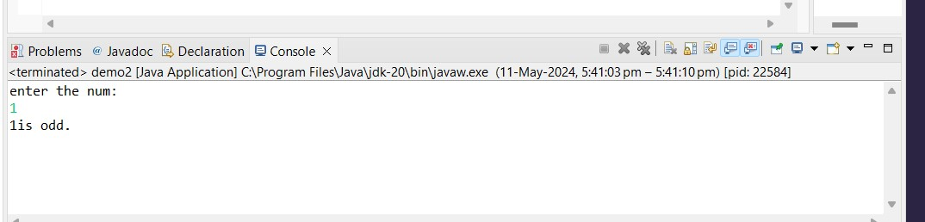

4.Write a java program to find greatest of 2 numbers.

**ackage** hello3;

**import** java.util.*;

**public** **class** sheru {

**public** **static** **void** main(String[] args) {

Scanner scanner = **new** Scanner(System.***in***);

System.***out***.print("Enter the first number: ");

**double** num1 = scanner.nextDouble();

System.***out***.print("Enter the second number: ");

**double** num2 = scanner.nextDouble();

**double** greatest = *findGreatest*(num1, num2);

System.***out***.println("The greatest number is: " + greatest);

}

**public** **static** **double** findGreatest(**double** num1, **double** num2) {

**if** (num1 > num2) {

**return** num1;

} **else** {

**return** num2;

}

}

}

Output:

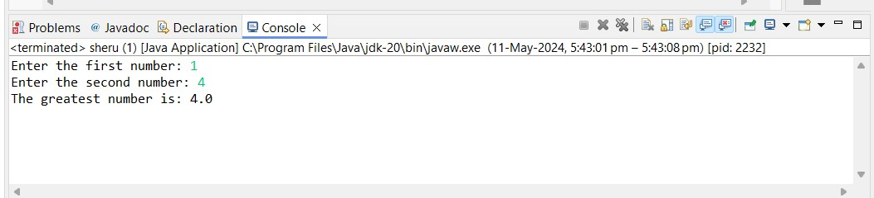

5. 5.Write a program to implement a basic calculator that takes input as a string expression and evaluates it.

**package** demo;

**import** java.util.Scanner;

**public** **class** calculator {

**public** **static** **void** main(String[] args) {

**int** num1 = 0;

**int** num2 = 0;

**char** Operator;

**double** answer = 0.0;

Scanner scan = **new** Scanner(System.in);

System.out.println("Enter number");

num1 = scan.nextInt();

System.out.println("Enter number");

num2 = scan.nextInt();

System.out.println("operater");

Operator = scan.next().charAt(0);

**switch**(Operator) {

**case** '+' : answer = num1 + num2;

**break**;

**case** '-' : answer = num1 - num2;

**break**;

**case**'*' : answer = num1 * num2;

**break**;

**case** '/' : answer = num1 / num2;

**break**;

}

System.out.println(num1+" " + Operator + "" + num2 + "" + "="

+answer);

}

}

Output:

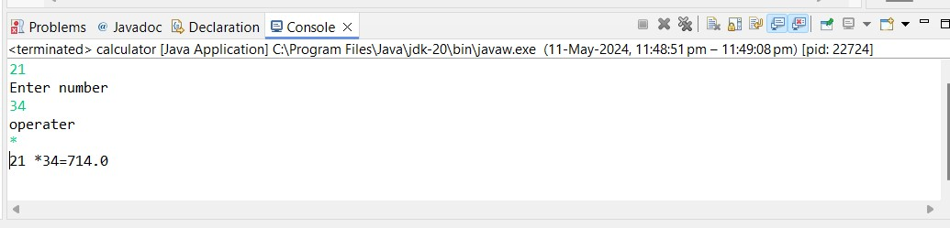

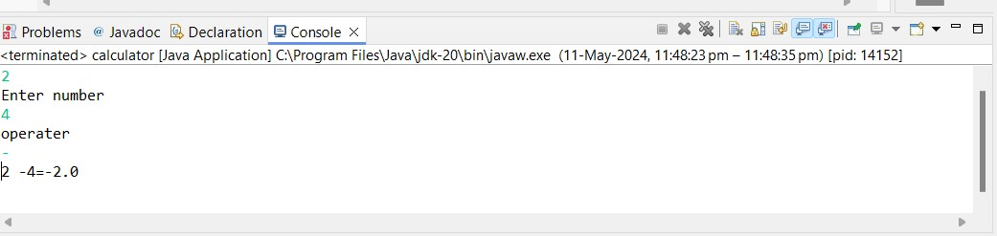

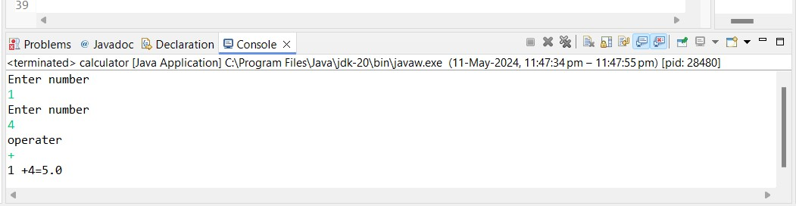

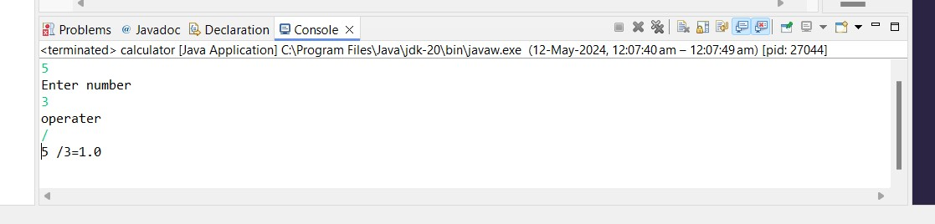

6.Write a Java program that takes an age input from the user and determines if they are eligible to vote (considering the legal voting age)

**package** demo;

**import** java.util.Scanner;

**public** **class** votingEligibility {

**public** **static** **void** main(String[] args) {

// **TODO** Auto-generated method stub

Scanner scanner = **new** Scanner(System.***in***);

System.***out***.print("Enter your age: ");

**int** age = scanner.nextInt();

**if** (age >= 18) {

System.***out***.println("You are eligible to vote.");

} **else** {

System.***out***.println("You are not eligible to vote yet.");

}

}

}

Output:

